1. Download git hub
2. Create a directory “MMS”
3. Cd MMS
4. Open bash prompt(shell)
5. Setup Git

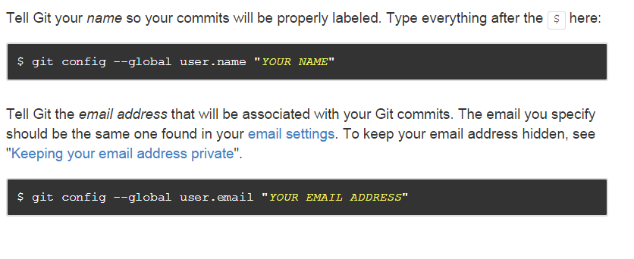

1. Clone MMS branch. To clone brunch execute below command(will pull all the code to ur system)

git clone <https://github.com/parag2borah/MMS.git>

1. All Server code n doc will pulled to ur local base on master branch
2. Add SSH key to profile for pass word less auth. (**Optional**)

<https://help.github.com/articles/generating-ssh-keys/>

Git commands

1. git status

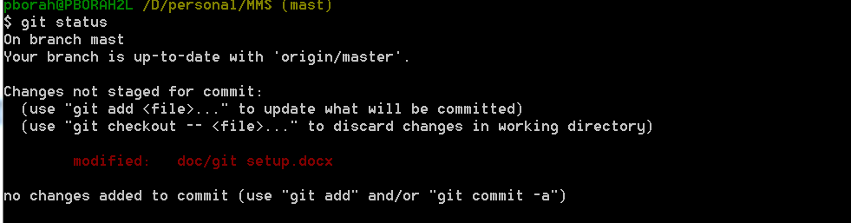

1. git pull (get the latest code)
   1. git pull -- rebase (get the latest code & rebase ur local code)

Note :: For conflict u need to change manually in ur code.

1. git gui
   1. click on new commit & add comment

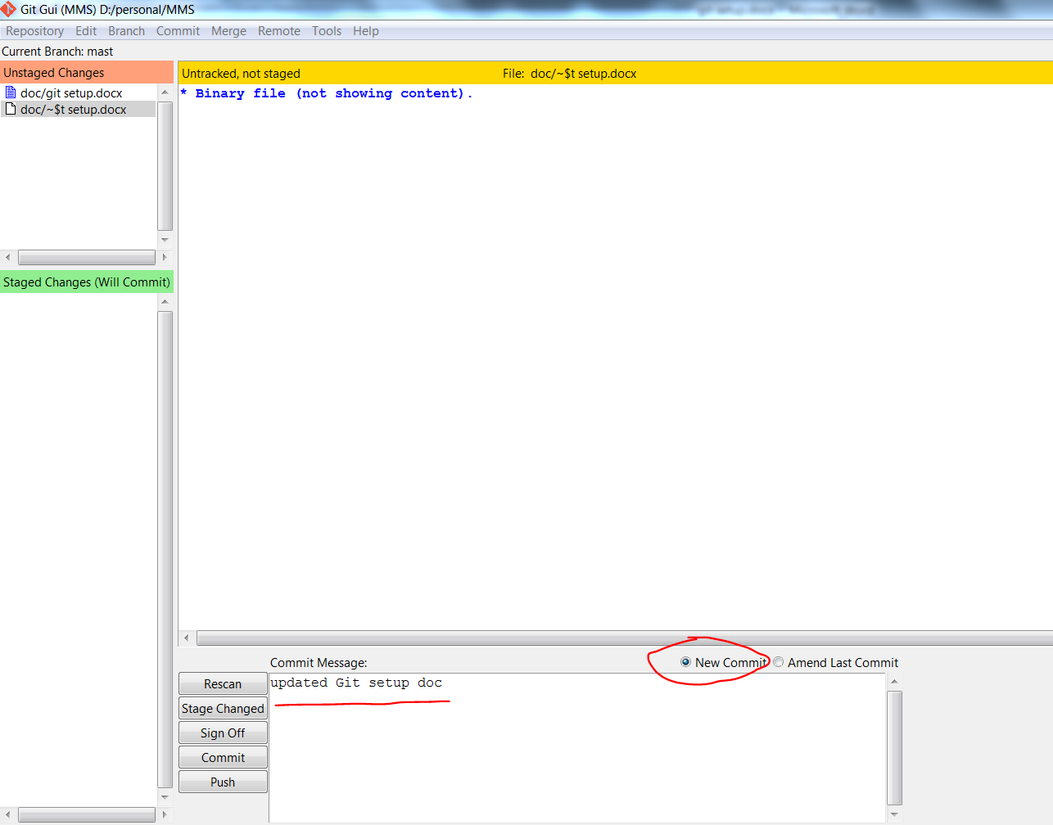

* 1. Click on stage to commit

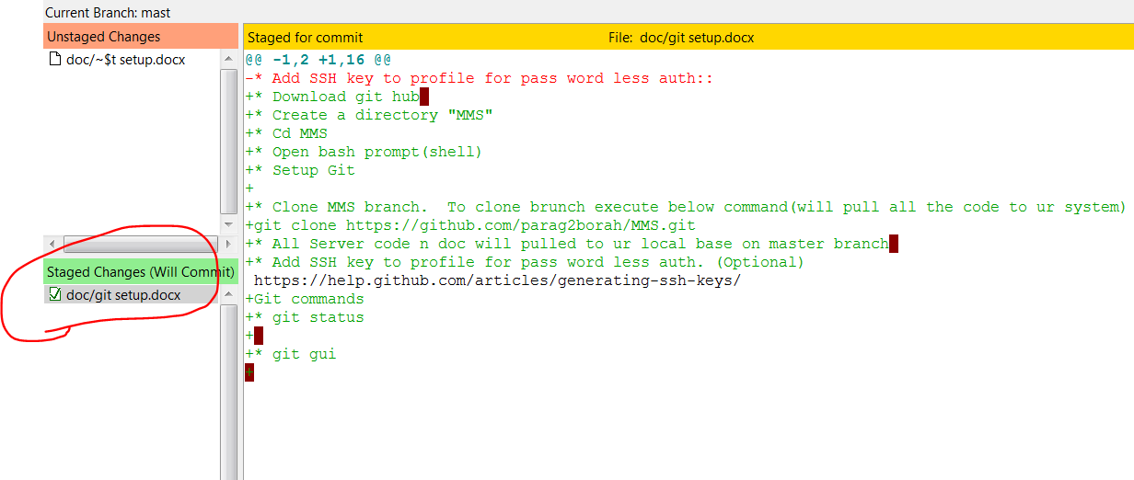

* 1. Click on commit

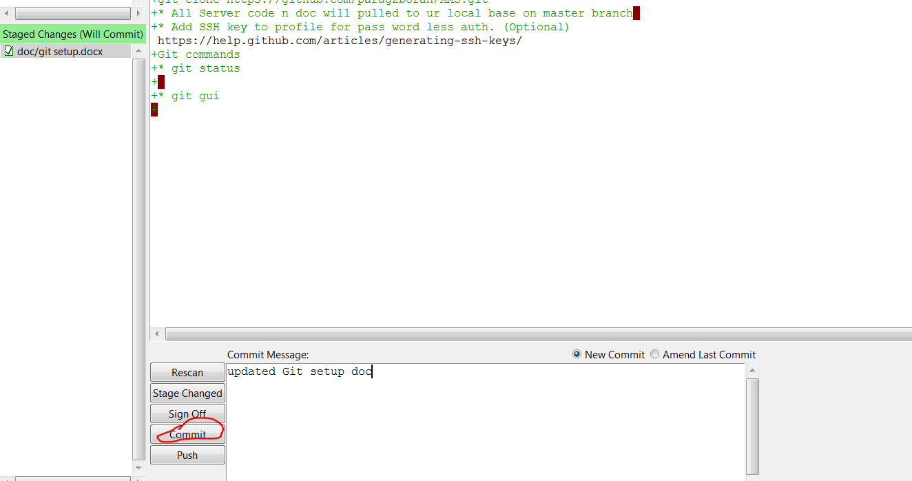

1. git push origin HEAD:master